Supplement C: Results with Hydrologic Benefit Function based on Chinook juvenile abundance
Claire Kouba
2026-02-13
Table 1: Coefficients for the Hydrologic Benefit function, an emperical estimate of ecological services provided to Chinook salmon by specific functional flows. The predicted value is in units of log10(juvenile abundance) produced, modeled using only hydrological factors.
Predictor | Value | Greater Hydrologic Benefit value associated with
Intercept | 5.450 | Intercept Term
w1_Wet_BFL_Mag_50 | -0.309 | Smaller wet season baseflows (as eggs and hatchlings)
## png
## 2
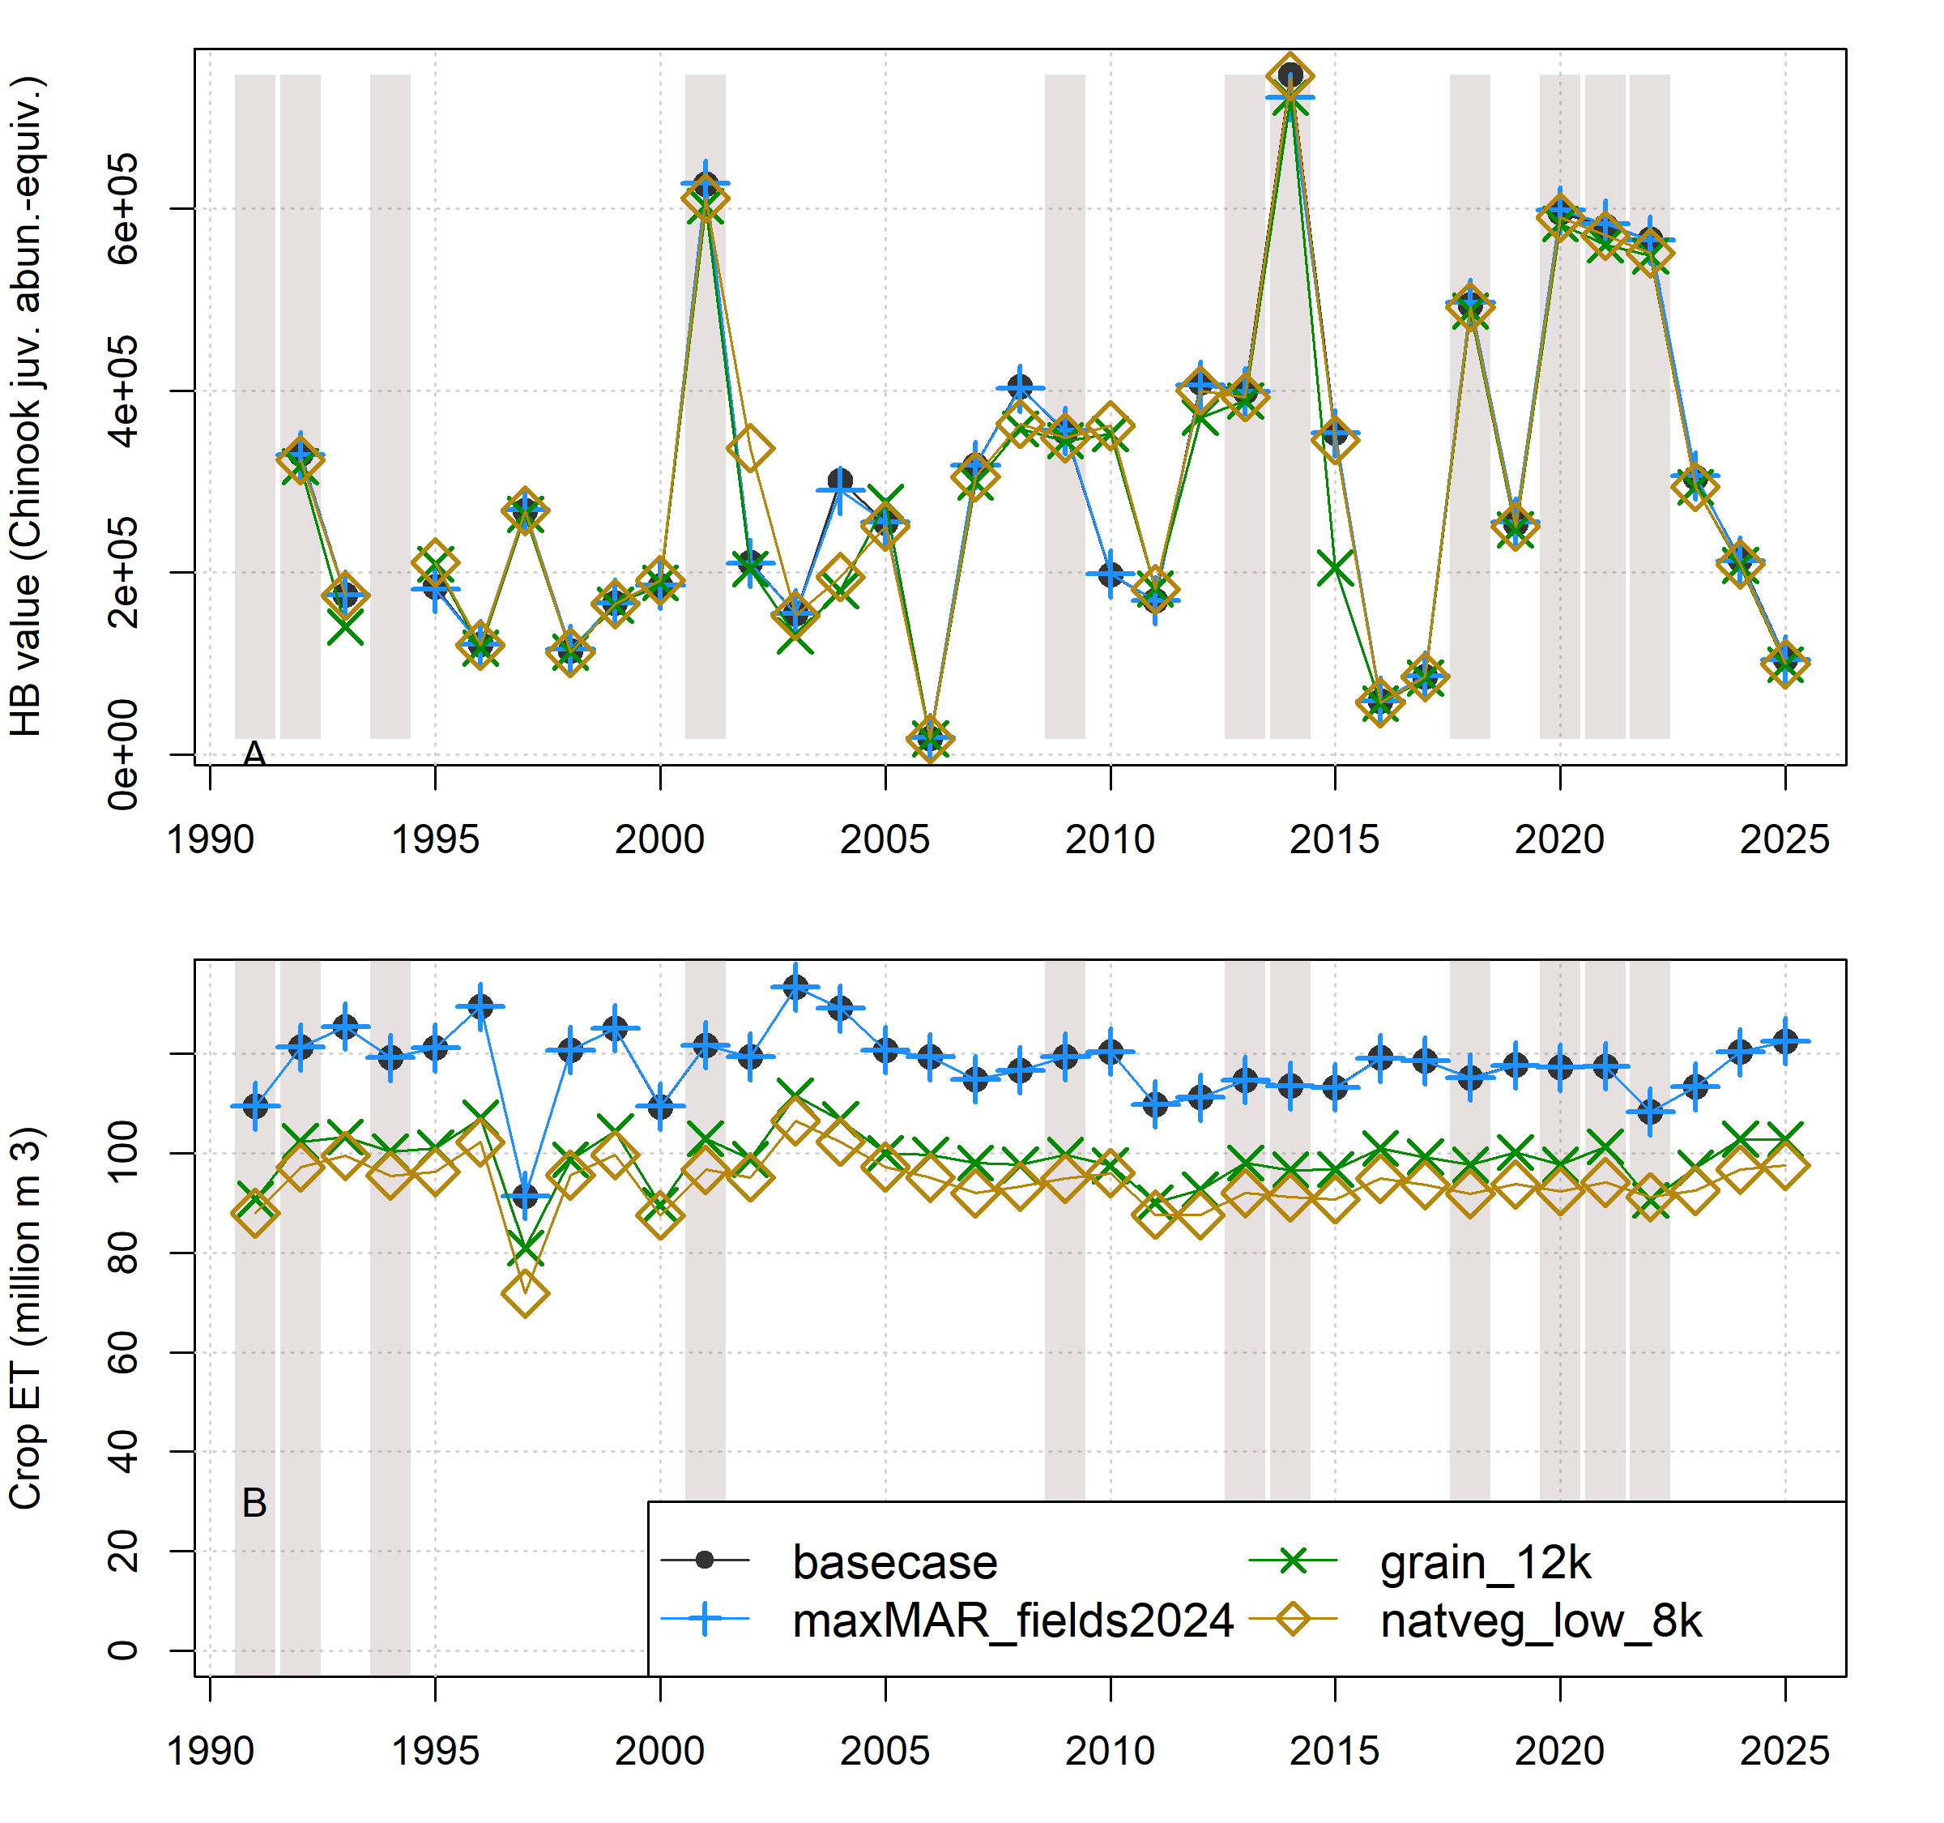
Figure 1: Comparison of annual performance in two objective functions (Hydrologic Benefit and ET, representing environmental and agricultural objectives, respectively) for brood years 1991-2025. The scenarios pictured are basecase (black circles) and a scenario from each of three categories: Enhanced Recharge, Crop Change, and Native Vegetation (Low ET). Dry-type water years (vertical bars) are 1991, ’92, ’94, 2001, ’09, ’13, ’14, ’18, and ’20-’22.
## png
## 2
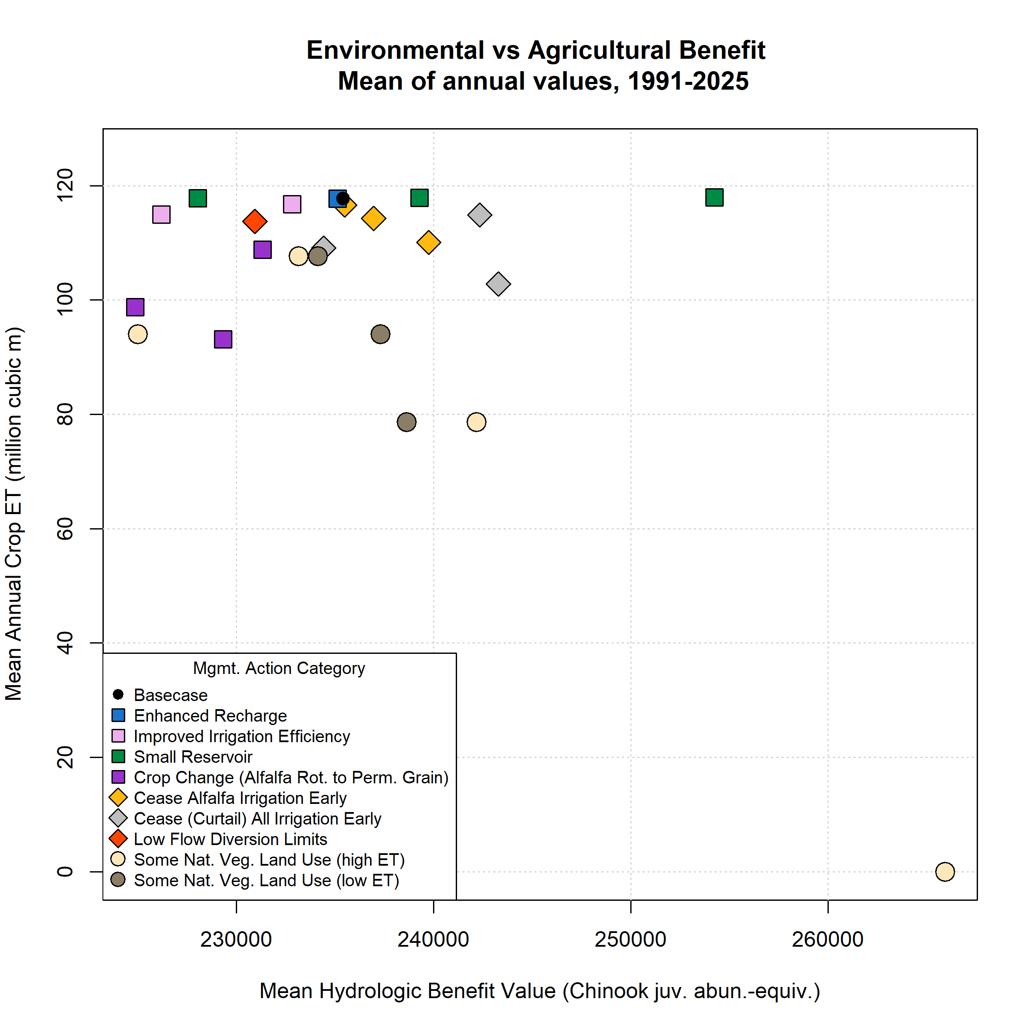
Figure 2: Environmental and agricultural objective function performance (in terms of Hydrologic Benefit, or HB, value; and crop ET volume) for basecase (black circle in upper left) and 25 management scenarios. Symbol x and y coordinates are the average of 35 annual HB and ET values for each scenario over the full model period (water years 1991-2025); for exampe time series of annual values, see previous figure.
## png
## 2

Table 2: Scenario attributes for 25 scenarios. Values in the Mean Hydrologic Benefit (HB) and Mean ET columns are averages of 35 annual values for each scenario. Efficiency not calculated for scenarios with no average ET loss.
Scenario ID | Category | Feas. | Mean HB / 1000 | Mean ET | Pareto | Efficiency
basecase | basecase | 0 | 235.41 | 117.76 | Yes | --
alf_curtail_07.15 | AlfIrr | 1 | 239.76 | 110.09 | Yes | 0.28
alf_curtail_07.31 | AlfIrr | 1 | 236.97 | 114.26 | Yes | 0.22
alf_curtail_08.15 | AlfIrr | 1 | 235.50 | 116.61 | Yes | 0.04
curtail_all_07.15 | Curtail | 1 | 243.29 | 102.83 | Yes | 0.26
curtail_all_07.31 | Curtail | 1 | 234.43 | 109.13 | -- | --
curtail_all_08.15 | Curtail | 1 | 242.35 | 114.91 | Yes | 1.22
eflows25_div_lims | FlowLims | 1 | 230.95 | 113.75 | -- | --
grain_12k | CropCh | 2 | 224.88 | 98.75 | -- | --
grain_14k | CropCh | 2 | 229.34 | 93.16 | -- | --
grain_6k | CropCh | 2 | 231.33 | 108.81 | -- | --
irr_eff_0.1 | IrrEff | 2 | 232.82 | 116.74 | -- | --
irr_eff_0.2 | IrrEff | 2 | 226.20 | 114.98 | -- | --
maxMAR_fields2024 | EnhRch | 3 | 235.14 | 117.75 | -- | --
natveg_high_12k | NatVegH | 2 | 242.17 | 78.66 | -- | 0.09
natveg_high_4k | NatVegH | 2 | 233.16 | 107.70 | -- | --
natveg_high_8k | NatVegH | 2 | 225.00 | 94.02 | -- | --
natveg_high_all | NatVegH | 2 | 265.93 | 0.00 | Yes | 0.13
natveg_low_12k | NatVegL | 2 | 238.64 | 78.66 | -- | 0.04
natveg_low_4k | NatVegL | 2 | 234.14 | 107.70 | -- | --
natveg_low_8k | NatVegL | 2 | 237.31 | 94.02 | -- | 0.04
natveg_low_all | NatVegL | 2 | 229.07 | 0.00 | -- | --
reservoir_etna | Res | 4 | 239.29 | 117.87 | Yes | --
reservoir_french | Res | 4 | 228.05 | 117.84 | Yes | --
reservoir_shackleford | Res | 4 | 254.23 | 117.98 | Yes | --
## png
## 2
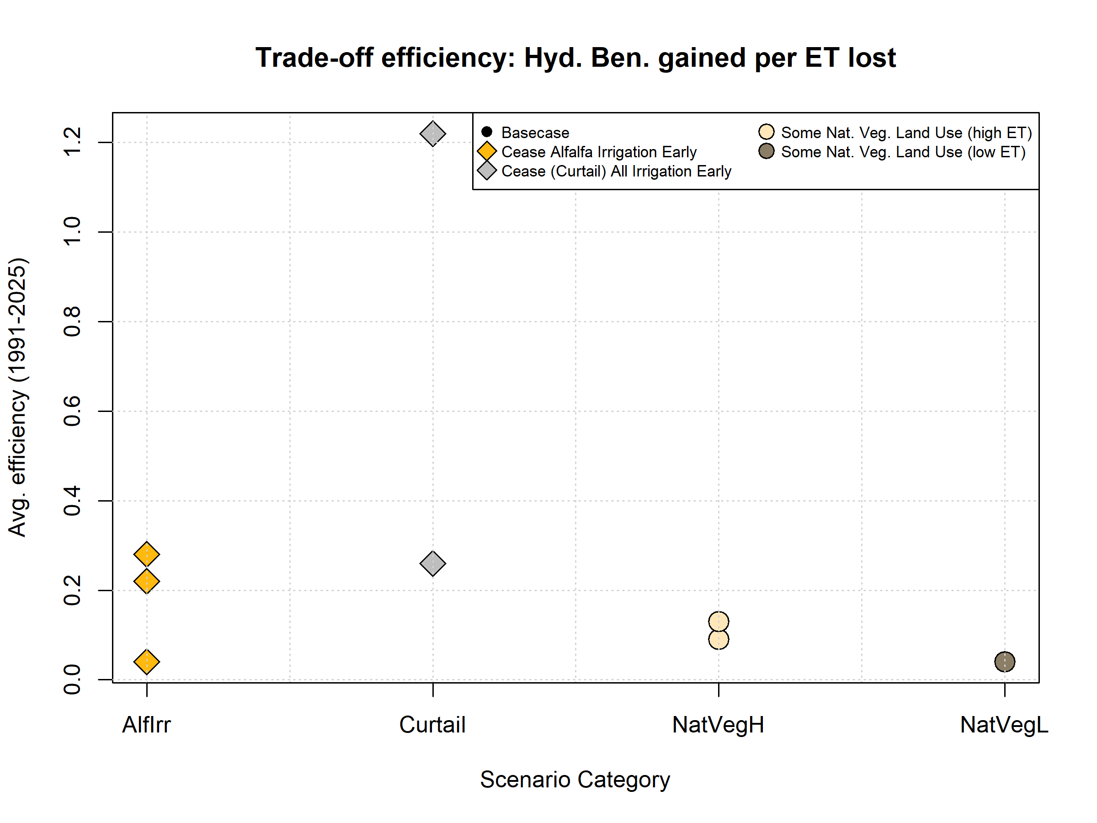
Figure 3: Scenario trade-off efficiencies, or average Hydrologic Benefit value (a proxy for environmental benefit) gained per crop ET value lost (a proxy for farmer cost) (normalized to average basecase HB and ET values, respectively), in all 35 years. Some scenarios are excluded if they have no or negative ET loss, producing infinite or negative efficiency values.

